# Assignment4 Documentation

Group 10

Siyu Liu ([Sliu9412@conestogac.on.ca](mailto:Sliu9412@conestogac.on.ca))

Wang Meng([Mwang7824@conestogac.on.ca](mailto:Mwang7824@conestogac.on.ca))

## Login Page (First Page)

The login page consists of a form to let the user enter name, it’s a required field cannot be empty; other pages will not allow access before login.

After user login, the username will be stored in $_Session[‘guest’], and PHP will use “header()” method to redirect to Meat Products Page as follows.

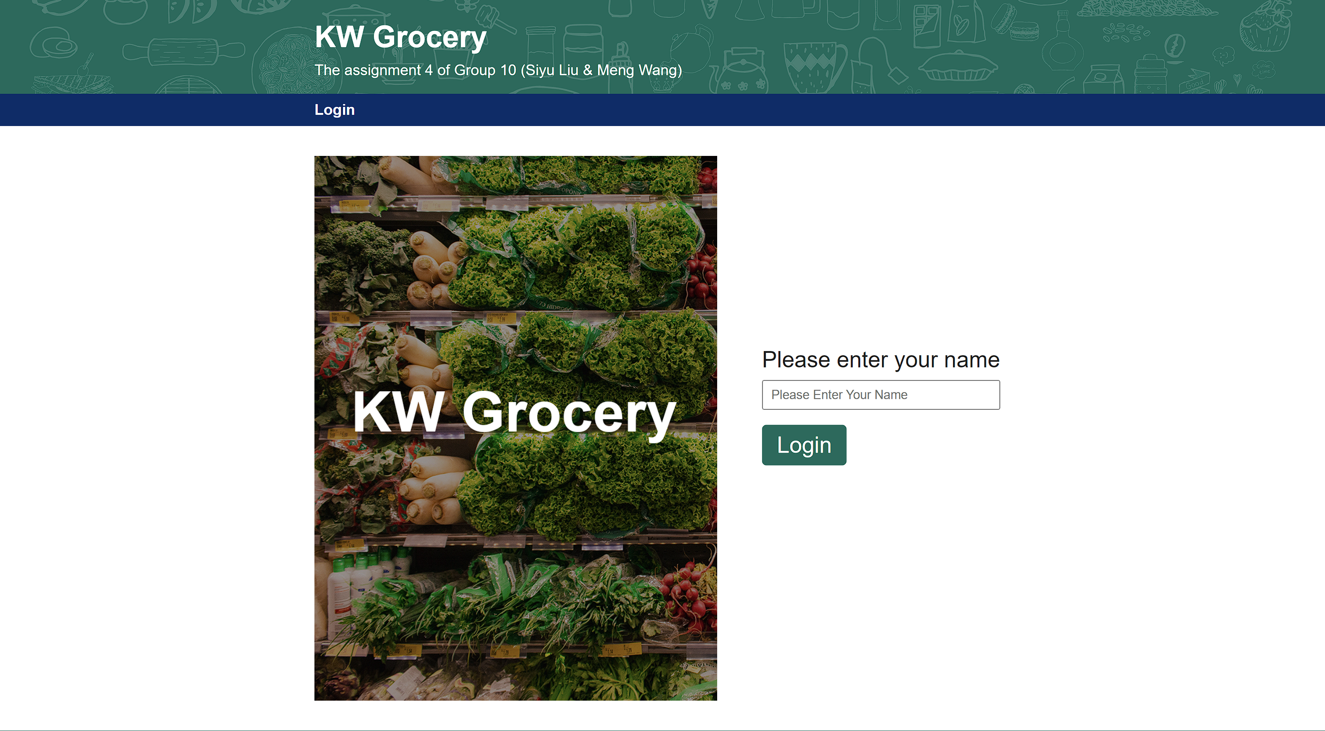

## Meat Products Page (Second Page)

Meat Products Page is generated by key-value pairs. All the data of products is stored together and identified by their unique id.

JavaScript also plays an important role, when moving to other pages via navigator or the “Prev” or “Next” buttons on the bottom the products list, it will modify a hidden text field’s value, and submit the form, to make the PHP redirect to the page we want. The submitted data will be recorded to PHP session.

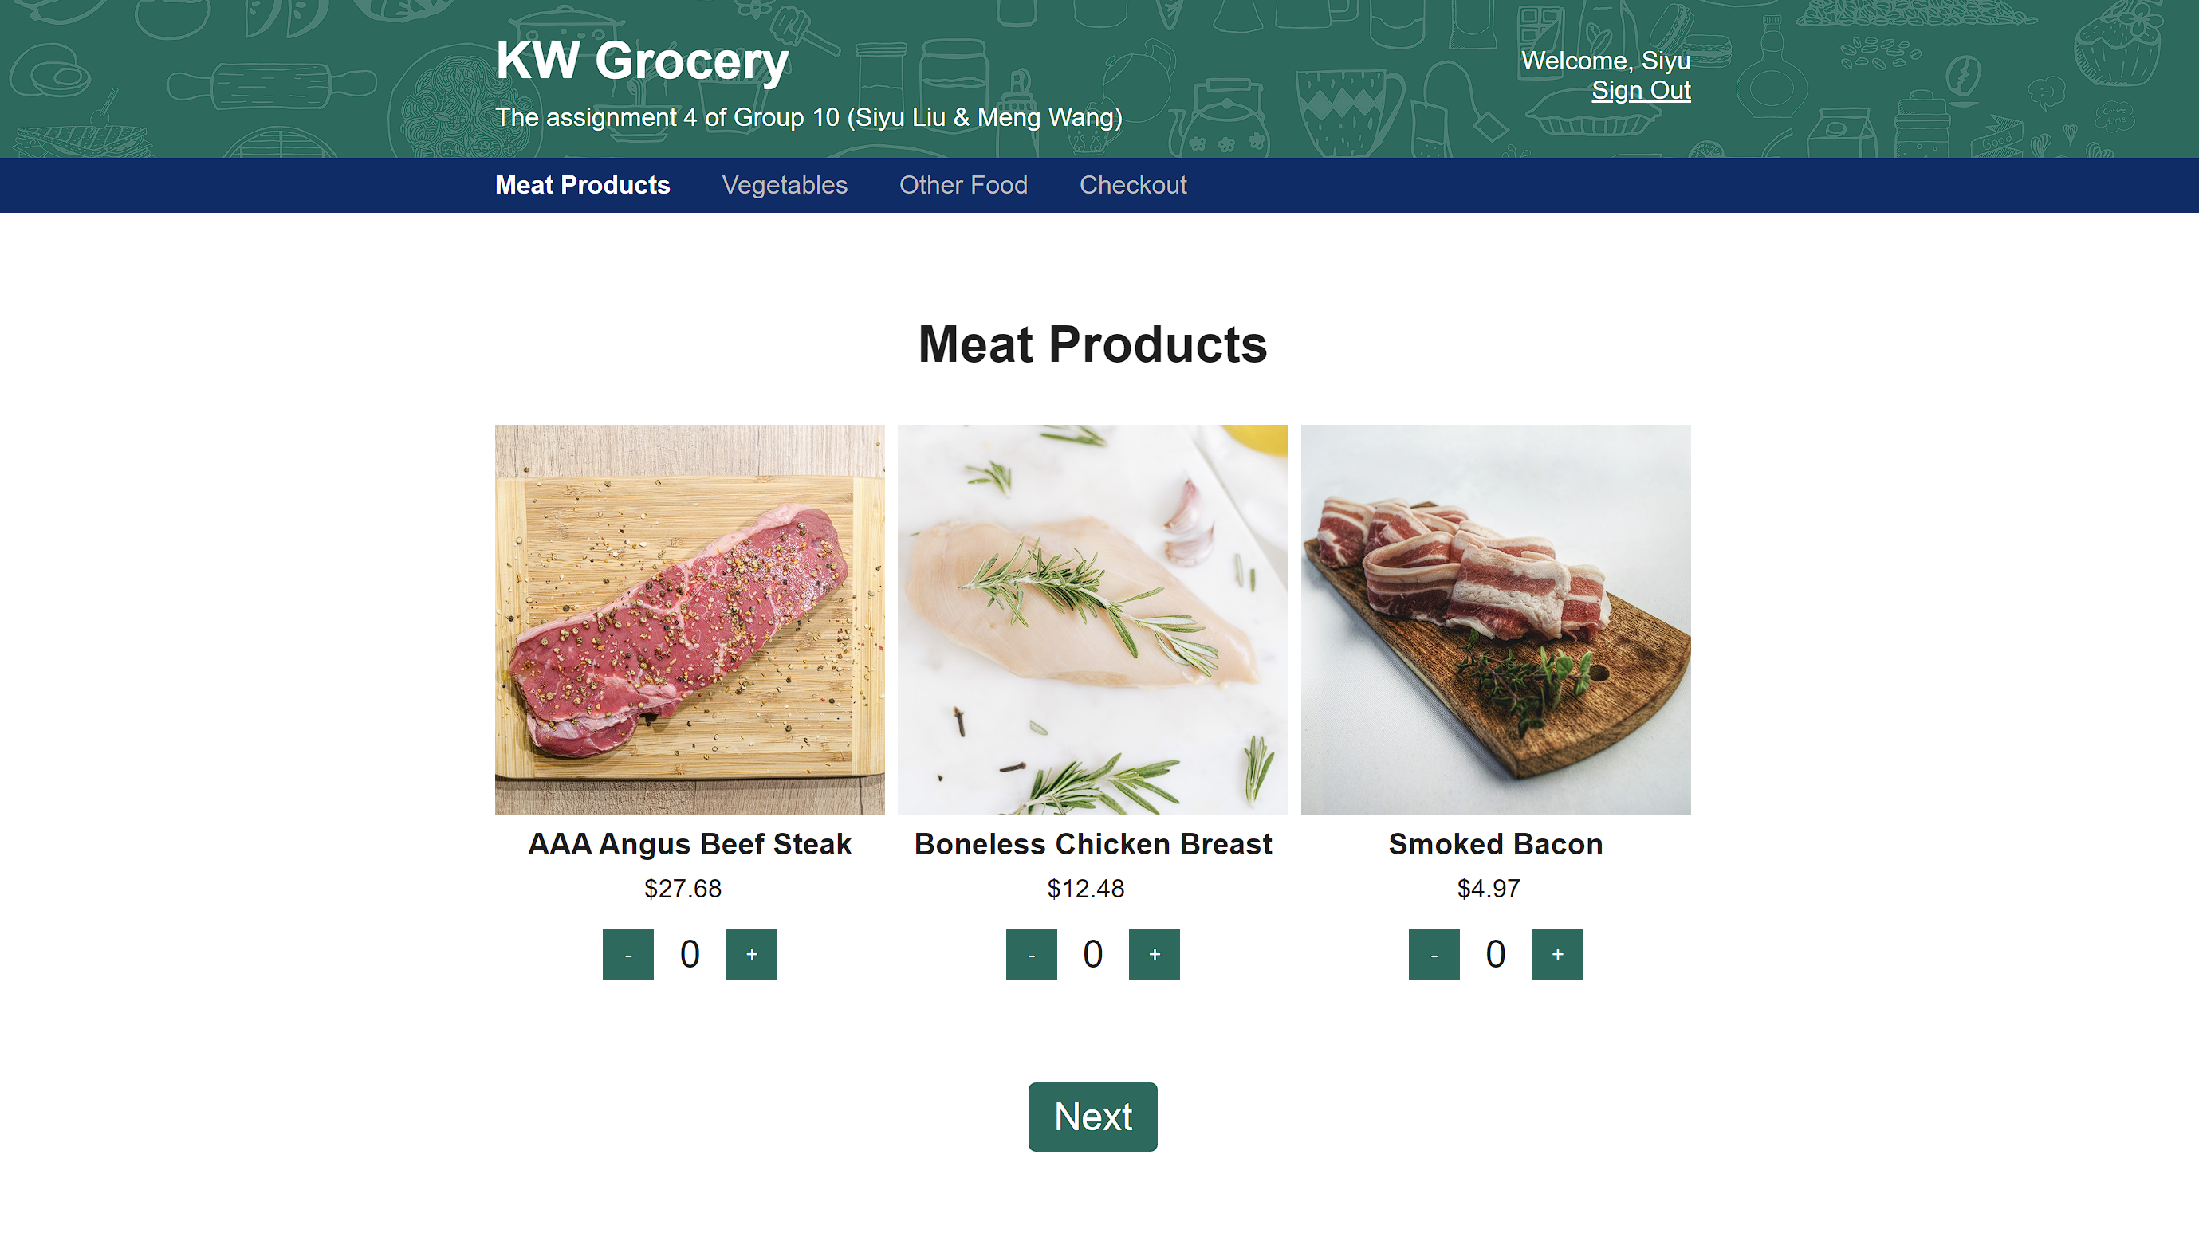

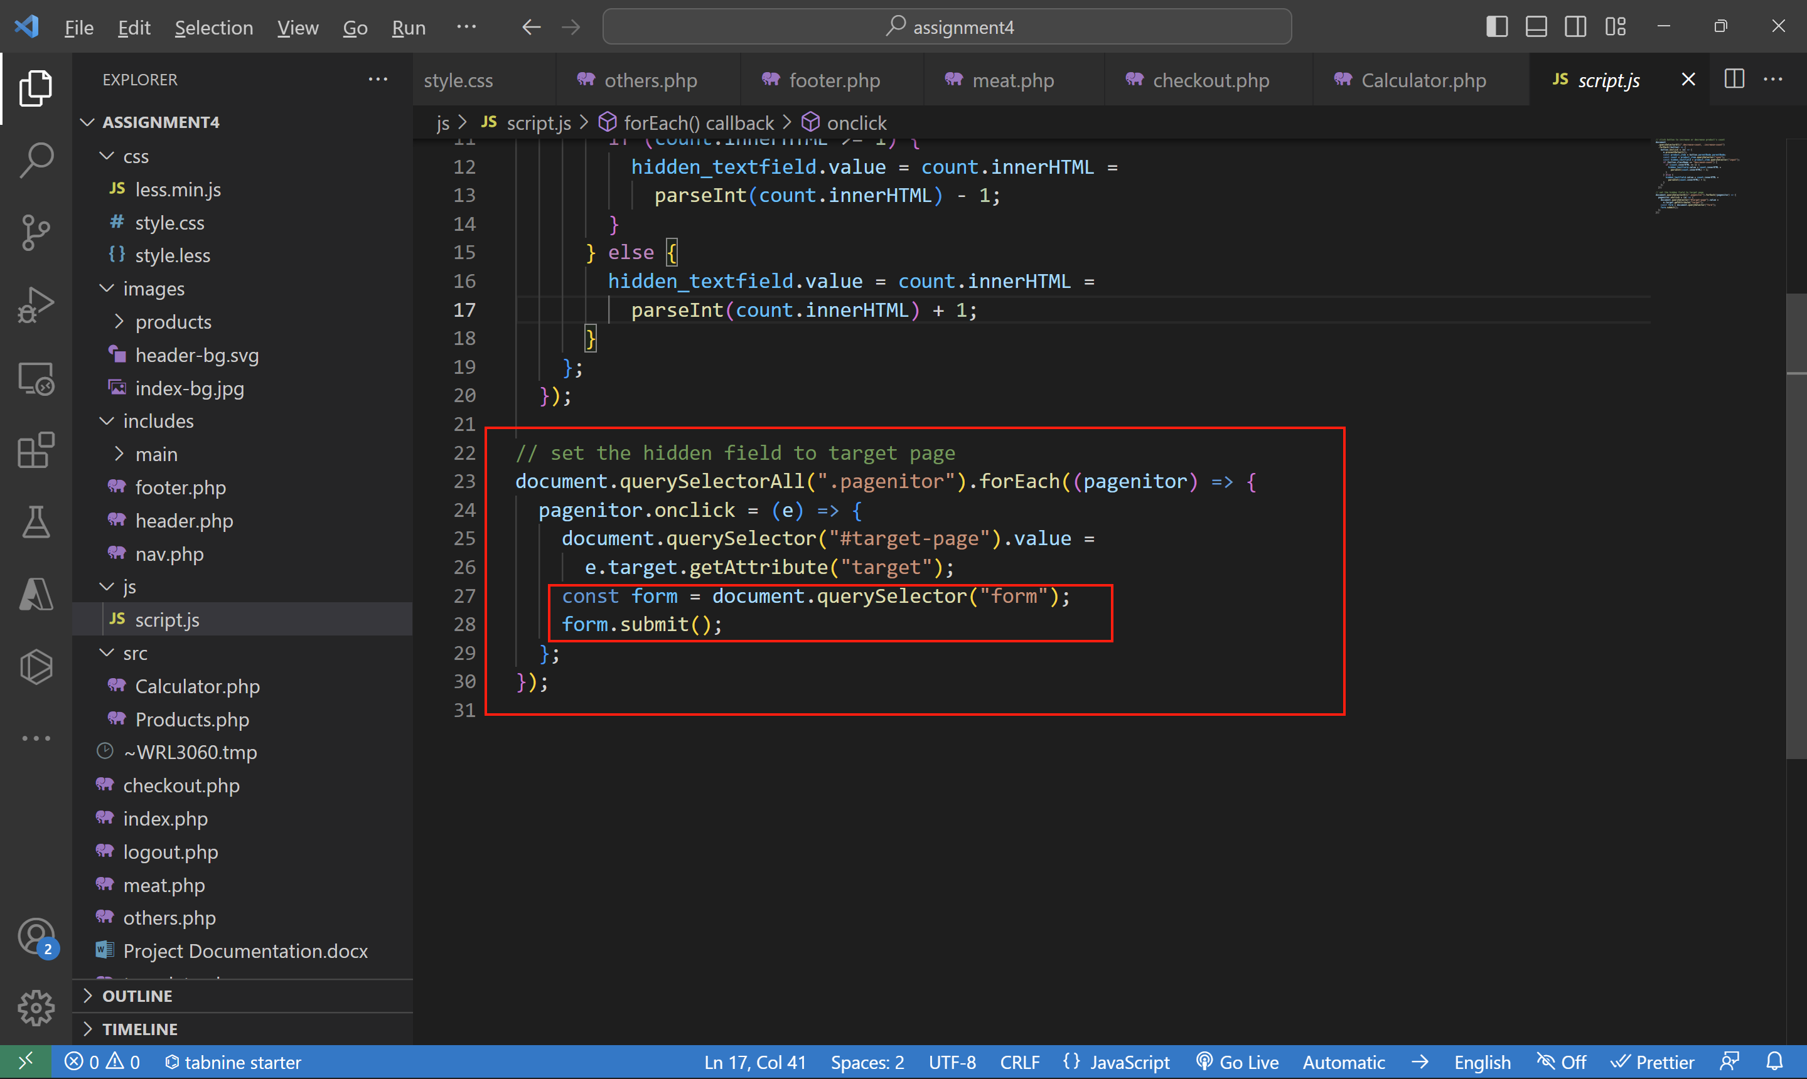

## Vegetable Page and Other Food Page

Like the Meat Page, these two pages also inherit template PHP file, the main difference is that the ids of the products, other logic is the same.

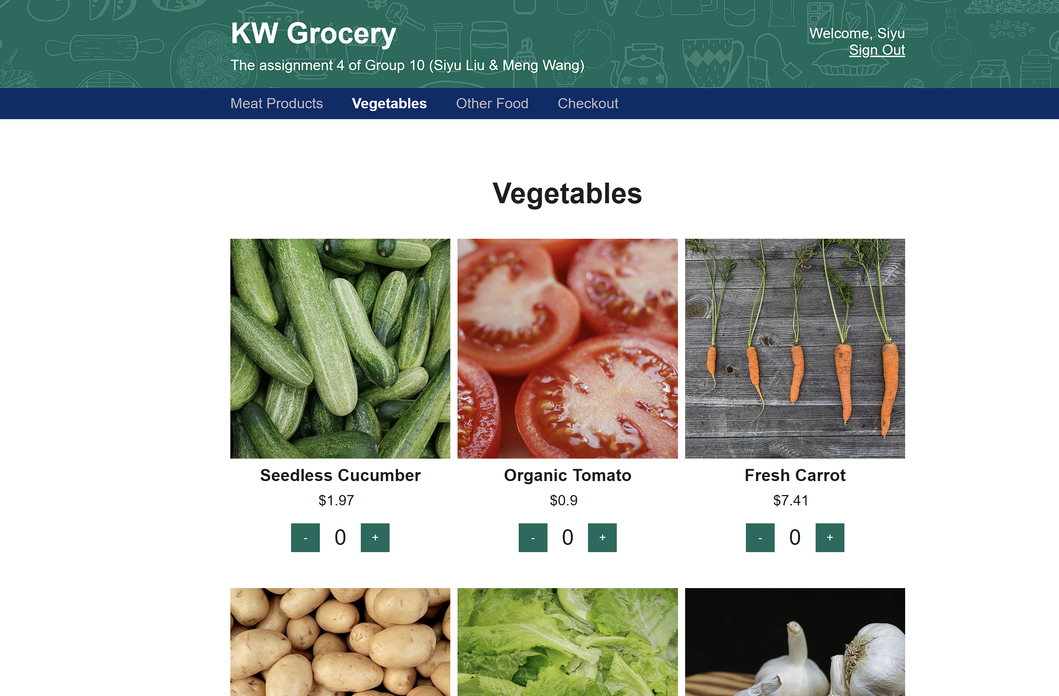

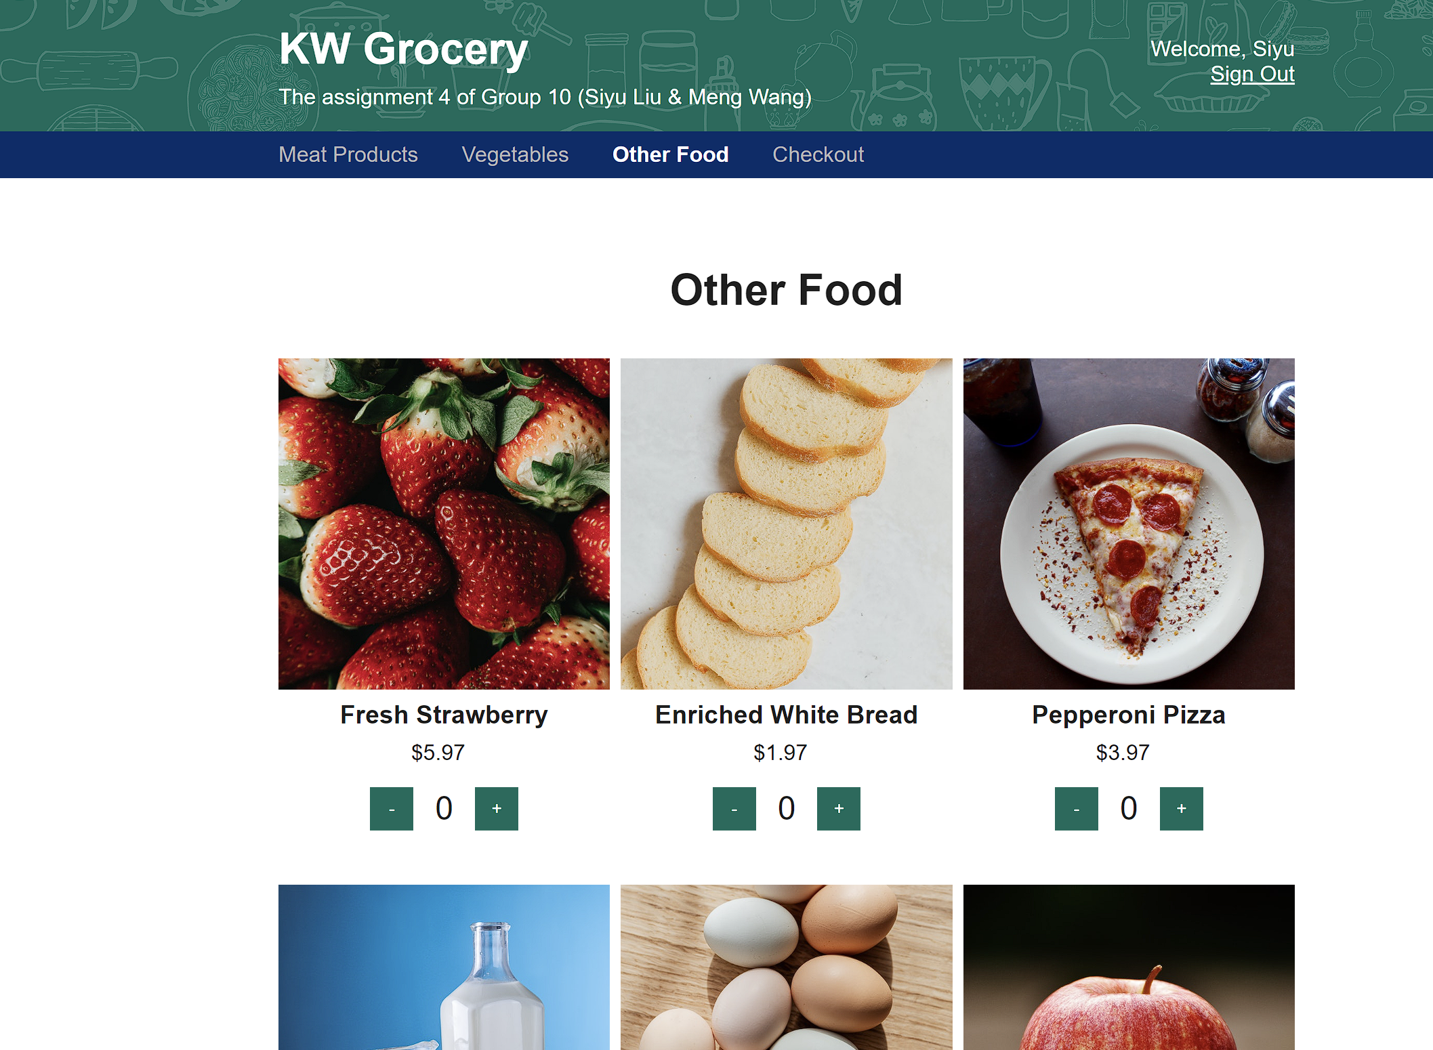

## Check Out Page

The check out Page will fetch the data from key-value pairs and session, to calculate the price and generate a table to display all the selected products.

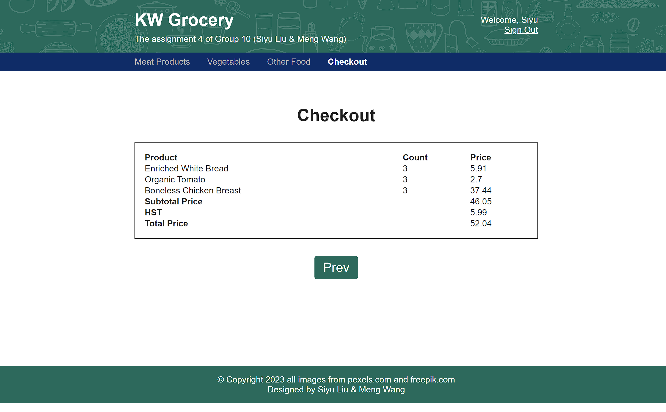

## Sign Out Page

The link to sign out is always on the header area of all the pages except the Login Page (Because after login, the user will not be able to visit the Login Page again). The Sign Out Page will not display anything but only destroy session, then redirect to the Login Page.

